Use the components below to set up an email in your platform. Click on the image to select it and then right click to “Save as a Picture” to your system or to Copy and then Paste (Ctrl P) into your email.

Subject Line: Have You Considered This Scary Possibility?

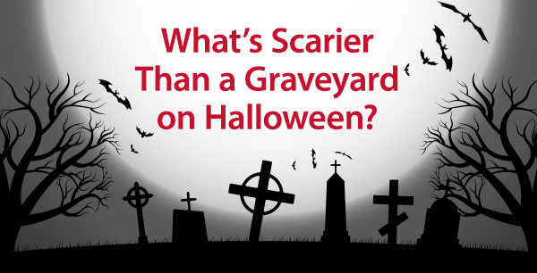

Dear <First>,

Halloween can be scary but it’s nothing compared to the medical bill nightmares caused by disabilities. If you are unable to work due to illness or injury, the one-two stab of losing a paycheck while gaining medical debt can bleed your savings accounts dry – even if you have health insurance!

If you don’t have disability insurance, you have a huge crack in your financial plan. Even if you have group disability insurance at work, you probably need a supplemental individual disability insurance policy to ensure you are properly covered.

Check out the attached infographic and call me for a quote or use my quote link below to request more information. I look forward to helping your ward off one of the most terrifying financial threats!

ADD QUOTE LINK HERE –   
(If you don’t have a personal quote link, contact Sue at DIS at 619.284.8444 X8445)

ADD EMAIL SIGNATURE HERE

(BE SURE TO ATTACH THE MEDICAL BILL INFOGRAPHIC TO YOUR EMAIL)